2018 WORKSHOP BOOKING FORM DANGER CLUB – April School holidays
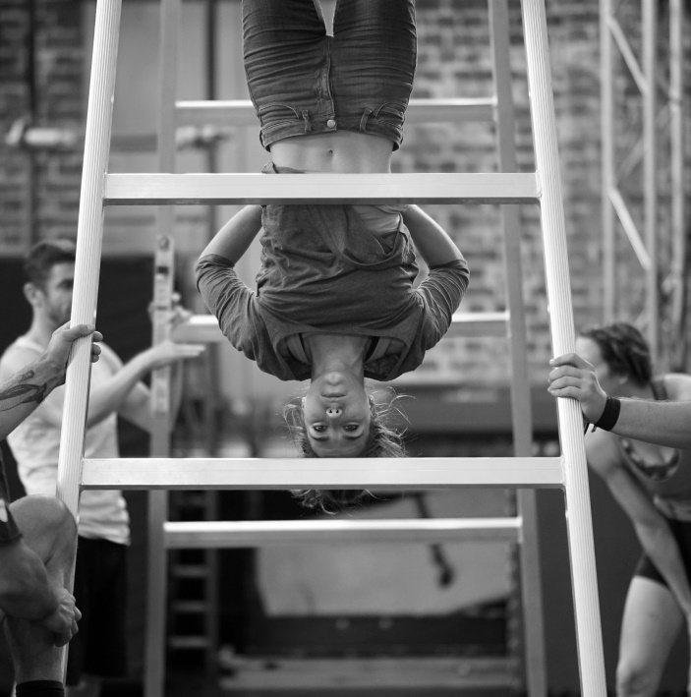
Are you aged between 7 and 18? Ever wanted to run away and join the circus? In April here’s your chance: join us for 4 days in an exclusive club to learn new tricks, explore the art of danger and present your very own show.

We want enthusiastic and adventurous kids to create a brand new theatre experience alongside acrobats from the world famous Circa Contemporary Circus.
Danger Club brings together local kids and Circa’s acrobats (people who live danger every day) to perform a brand new show for friends, family and the community.

Danger Club will be meeting in a secret location within the Northern Festival Centre, to inspire and challenge you in unexpected, exciting, and amusing ways to create a unique physical theatre performance.

So take a leap of faith and join Danger Club in the April school holidays– everything’s about to change.

Circa Contemporary Circus is one of the world's leading performance companies. Since 2004, from its base in Brisbane, Australia, Circa has toured the world - performing in 39 countries to over a million people. Circa's works have been greeted with standing ovations, rave reviews and sold-out houses across six continents. They will be performing Reclaimed Pianos at the Northern Festival Centre, Port Pirie on Thurs 19th April, and in Burra Town Hall on Sat 21st April

Workshop Cost |  | $50 for 4 days + includes a ticket for a guest to attend the Performance Thurs eve.  *Please note you must be available to attend the whole week.
Capacity |  | 8-12 students in the morning Junior workshops (aged 7-11 years)  8-12 students in the afternoon Senior workshops (aged 12- 18 years)
WORKSHOPS |  | Type | Date and time | Number of participants | Age of participant |  | Total Cost
Danger Club Circus Skills |  | Junior | Mon 16th April 9am-12pm  Tues 17th April 9am-12pm  Wed 18th April 9am-12pm  Thurs 19th April AM Dress rehearsal  5-7pm Performance
Danger Club Circus Skills |  | Senior | Mon 16th April 2-5pm  Tues 17th April 2-5pm  Wed 18th April 2-5pm  Thurs 19th April AM Dress rehearsal  5-7pm Performance
TOTALS
CONTACT DETAILS | Participant Name:  Contact:  Postal Address:  Town: Postcode:  Phone:(w) (mob)  Email:  Please record any special needs & numbers of students with disabilities ie wheelchairs, vision/hearing impaired:  Any previous experience with circus/theatre/dance/gymnastics?  Please provide the following for evaluation purposes.  No. of ATSI students No of NESB students  Do you require an invoice prior to payment? YES / NO

PLEASE SEND YOUR BOOKING FORM TO
Northern Festival Centre PORT PIRIE northern@countryarts.org.au Ph: (08) 8633 8500

Staff will be in touch to let you know if your booking is confirmed, please be aware there is limited capacity for the workshop program, get in early to secure your place.
Participation & Image Release Disclaimer

Movement of all types can involve risk of personal injury. Country Arts SA takes all reasonable care in the conduct of
workshops, rehearsals and performances that are a part of the Country Arts SA Performing Arts Season (the program) and will accept no responsibility for injury or loss caused during the program or whilst participants are in or near the venue. All community members, students and participants attending a workshop, rehearsal or performance of the program (participant) are responsible for ensuring that they are physically and mentally fit for the program, and during workshops, rehearsals and performances they must at all times take care of their own personal safety.
The participant, and where the participant is under 18 years of age, a guardian, warrants and certifies that:
- the participant is fully responsible for the safety, management and care of their bodies during the program
- the participant is not currently injured or currently under any medical or rehabilitation supervision for any old or re-occurring physical injuries or health conditions that might be effected through the course of this activity
- the participant is not the subject of an ongoing Workers Compensation claim
- the participant will immediately inform the facilitator of any physical difficulties or injuries that occur
- the participant will report to the Venue Manager, Stage Manager or Assistant Stage Manager to complete an
incident report within two hours of an injury or incident occurring
where the participant has exception to any of this warranties, the participant MUST speak to the Venue Manager, PRIOR to participating in the program and may be required to complete further information space on this form.

IMAGE RELEASE DISCLAIMER:
I give permission for Country Arts SA to take photographs and use images of students attending workshops/performances for future marketing and promotional purposes. If students cannot be photographed I will advise the venue manager in advance of a performance/workshop.
Parent’s Signature: Date:

STUDENT Performance - danger club
About the Show | Safe things are boring. Danger is fun. And that’s the specialty of circus - the art of danger. With Circa’s Danger Club, take a leap of faith with Danger Club – everything’s about to change.  A group of young people from your community have been gathering in a secret location, seeking the thrill of danger. They’ve been creating in a room with artists from Circa Contemporary Circus - people who live danger every day. Together they've been exploring the very idea of danger and will use it to inspire and challenge you in unexpected, exciting, and amusing ways, when you are granted entry to the Danger Club.  For a strictly limited capacity, the performance showings will be at 5.30pm, and 6pm Thurs 19th April
Circa Performance - Reclaimed pianos
About the Show | Reclaimed Pianos Thurs 19th April 7pm  Northern Festival Centre Ballroom  Circa Contemporary Circus are in town to present Reclaimed Pianos, their regionally developed performance commissioned by Country Arts SA. Stay on after the Danger Club showing to see the ensemble perform the intimate show that taps into the piano's magical ability to transport us through time and to other places.  Stunning, graceful and evocative, Reclaimed Pianos returns to South Australia after a sell-out 2016 regional tour. This intimate creation by internationally renowned company Circa, taps into the piano’s magical ability to transport us through time and to other places. As notes reverberate, they echo our memories of times before, places travelled and worlds to be discovered. From classical recitals to family sing-alongs: pianos have stories to tell.  In this beautiful work, the incredible physicality of Circa’s acrobats will breathe fresh life to music layered with a soundscape of local voices. In the centre of this chamber of circus is a guest appearance by a piano sourced from the community – a gem of hidden history and dreams.
Tickets
Danger Club student performance  Guest tickets | NB 1 guest ticket included in registration  Name of free guest__________________________________________________  Preferred Time: □ 5:30pm □ 6pm  Additional Guests Number: ___ Tickets @$10
Double bill Ticket Package | To attend both performances, take advantage of special package price  Includes 5.30-6pm / 6-6.30pm Danger Club student performance  + 7-8.10pm Reclaimed Pianos by Circa performance  Adult: ____ Tickets @ $35  Child: ____ Tickets @ $20
 | TOTAL $___________________

