Cultural opportunity in a heritage Berri building

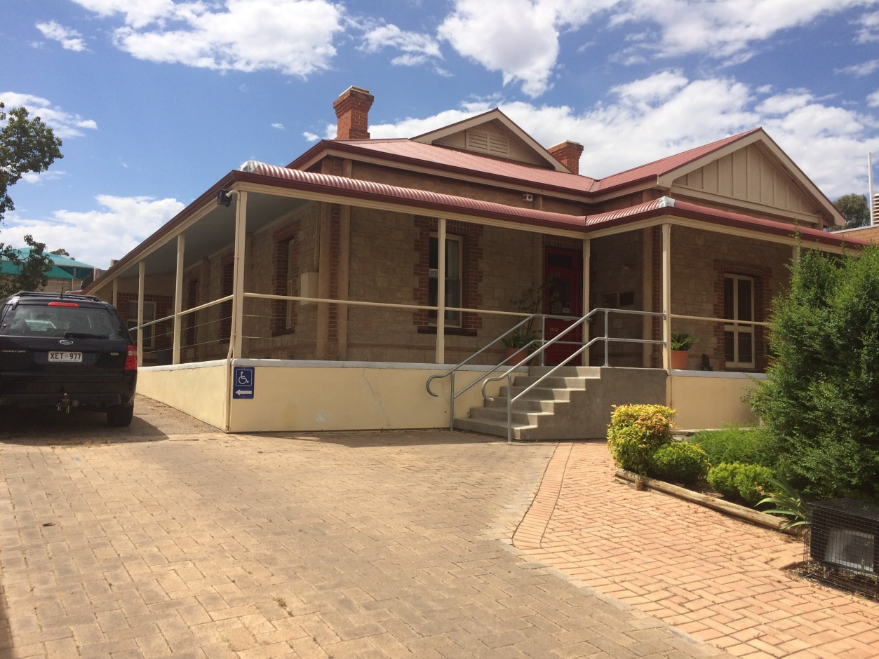

Key points
- 2-3 year opportunity potential
- Historic building in central location
- Drive way and front garden with activation potential
- Gallery hanging system and lighting installed
- Currently recognised as an arts and cultural space

Country Arts SA believes that arts and culture have the power to transform lives and communities and contribute to healthy, resilient and prosperous regional communities.

23 Wilson Street, Berri is a major asset ripe for new arts and cultural activation that can contribute to the vibrancy of the Riverland and act as a catalyst for tourism, employment and economic development.

Summary extract
The property at 23 Wilson Street, Berri will be available in 2017 for a suitable operator to activate. We are seeking an operator who can bring engaging and creative ideas to maximize the potential of this building and add to the cultural vibrancy and richness of the Riverland. The property will be offered for 2-3 years to the successful applicant.

The property
23 Wilson Street is in the heart of Berri’s CBD. Wilson Street offers specialty shops, eateries, services and Council Offices and Town Hall.

The property was originally built in 1917 as the “Old Irrigation Office” and in 1996 it was renovated by Country Arts SA to provide office and gallery space opportunities for the community. The building features:
- 5 main rooms suitable for offices, gallery or meeting rooms
- Kitchen, toilets, storage rooms and workshop area
- Wide verandah wrapping 3 sides of the building
- Parking on site
- Garden and courtyard area at the front of the building

Building area
Whole Building: 706m² (please note measurements below are approximate only)

Building uses
The building is required to be used for cultural purposes however this is a broad term which can include art, craft, design, music, fashion, photography, community and many other creative purposes.

The actual building is not heritage specific, however it is a great example of stone architecture in a public facility thus any external changes, especially to the façade, will require consideration and approval.

Costs associated with the opportunity
Whilst Country Arts SA does not require traditional rent to be paid on the property, there are costs associated with set-up and ongoing occupation of the property that the successful applicant will be responsible for.

For example:
- Utilities: Electricity, Water, Effluent Drainage
- Public Liability and your own business insurance as desired
- Fit out, furniture & establishment costs
- Regulatory application costs
- Basic property maintenance & cleaning
- Making good (returning the property to its original condition) at the end of the agreed period (and any extension thereof)
- Business costs such as marketing & promoting your project
- The payment of council rates if applicable

Further information
Country Arts SA will provide up to a 2 year initial term with an option to renew of 1 year, subject to commencement date and agreement of other terms.

The operator
We are seeking expressions of interest (EOI) from organisations or operators who have a creative, unique or engaging idea, which contributes to the Riverland’s culture and vibrancy. Partnerships are also encouraged between different sectors such as arts, health, community and tourism.

In your expression of interest (no more than 3 pages), you will be required to address the following:
- An outline of your concept
- Your plan for engaging with the community or bringing something unique or vibrant to the area
- Ideas for utilising the building
- An estimate of costs to set up the property for your venture
- Your plan for funding or meeting costs to establish and run the property

Inspection
We encourage you to inspect the property prior to submitting your interest. To register for an inspection please contact Rebecca Farrant on 0423 290 436 or rebecca.farrant@countryarts.org.au and provide your details. Please note Rebecca works part time from Wednesday to Friday.

The (EOI)
EOI’s close: 5pm Tuesday 28 February 2017

EOI’s to:
Country Arts SA
2 McLaren Parade, Port Adelaide SA 5015
Email: email@countryarts.org.au
Please include ‘23 Wilson Street’ in the subject heading

Should you have any questions, please contact Rebecca Farrant on 0423 290 436 or email rebecca.farrant@countryarts.org.au in the first instance.

